# **NGO COMMITTEE FOR SOCIAL DEVELOPMENT**

# **GRASSROOTS PROJECT: Call for Videos & Comments**

***Introduction***

*In November 2025 the United Nations will hold the Second World Social Summit to develop and commit to a detailed and measurable action plan for social development, including a focus on the Sustainable Development Goals. This is only the second time since 1995 that world leaders will meet to address people-centered development. Thus it is essential to bring to the UN the voice of persons at the grassroots to identify the most critical issues to be addressed at the Summit. Your input will help give priority to the most pressing issues for true “people-centered development.”*

*We are inviting people from around the world to share the challenges they face, what is needed and any solutions that work for them. We especially invite short video statements (2 minutes). We will use these to bring your voice to the officials at the United Nations and member states. Your input will be used by the NGO Committee for Social Development during the 63rd session of the Commission for Social Development.*

***Video Content Suggestions:***

First, briefly introduce yourself and your location. You do not have to use your whole name but a first name is helpful. State your location in general terms (example: My name is Maria and I am in a village in a rural part of Southern Mozambique).

Then, respond to the following:

***What are the most urgent issues and/or needs your community faces?***

***If you could speak to world leaders and governments at this Summit, what would you tell them is needed to eradicate poverty and create a society of greater equality and human dignity?***

***Please see the guidelines below for preparing your video to be sure it is of good quality.***

***When the video is complete, please send it by email to*** ***[csocdsurvey@gmail.com](mailto:csocdsurvey@gmail.com) no later than January 20, 2025 together with the enclosed consent form to allow us to use your video.***

**OPTION FOR RESPONDING IN WRITING**

*If you prefer, you can instead share your thoughts in words or respond both with a video and your thoughts on this form. If responding in words, please use the form with questions below.*

***About You:***

*Name (optional)___________________________________________________________*

*Country: ________________________ State/Province/Region­­­­­­­­­­­­­­­­­­­­­­­­­­­­­­­­­­­­­­­­­­­­­­­­­­­ ____________________*

*Are you in a city ___, town ____, or rural area ___? Very briefly, describe your area.*

*Are you a youth (18-25) ____, adult_____, elder____ (over 60)*

*Briefly, what type of work do you do?*

***The questions****:*

1. *What are the most urgent issues and/or needs your community faces?*
2. *If you could speak to world leaders and governments at this Summit, what would you tell them is needed to eradicate poverty and create a society of greater equality and human dignity?*
3. *What has your community already done that you can build on to bring about the needed change? Are there successful projects that you would like to share with others?*

Please return your comments to: [***csocdsurvey@gmail.com***](mailto:csocdsurvey@gmail.com) ***no later than January 20, 2025***

**GUIDELINES FOR VIDEOS**

***Instructions for Introducing Yourself on a Videos:***

Briefly introduce yourself. You do not have to use your whole name but a first name is helpful.

State your location in general terms (example: My name is Maria and I am in a village in a rural part of Southern Mozambique).

***For a Good Quality Video:***

Before you shoot your video, be sure to review the guidelines below.

**Lighting**: Make sure there is enough light on your face. If you are inside, you could face a window or a lamp. If you are outside, you should be looking in the direction of the sun. Cloudy days are often the best for recording.

**Background**: Remember that many people around the world will be seeing this video, so you should be comfortable with lots of people seeing what is behind you while you are recording.

**Background Noise**: Please make sure that you can be heard and that as much as possible there is no background noise, or it is not too loud that you cannot be heard.

**Recording**: Ask the person recording you to hold the phone or camera as still as possible. You can be sitting or standing, but make sure the video captures some space above your head down to your shoulders.

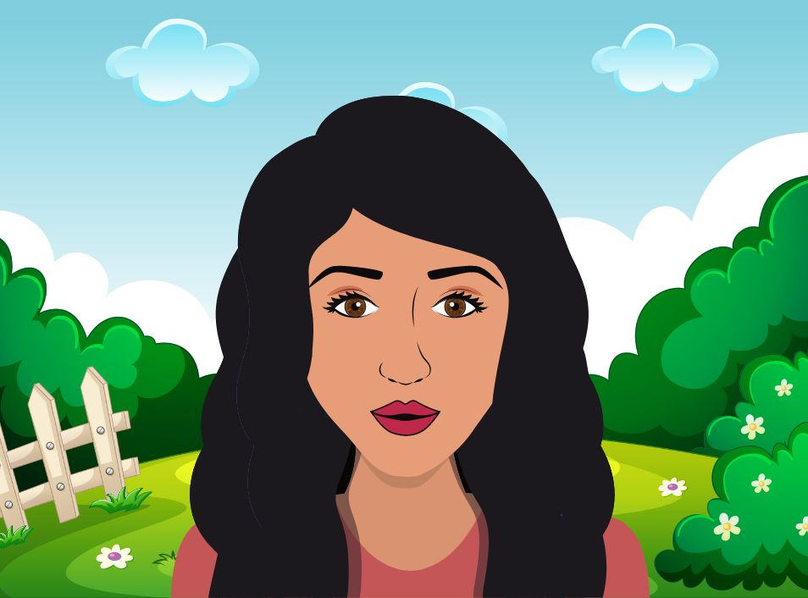

**Using a Smartphone**:

* Record with the phone held horizontally, so that the video is wide, not tall.



* Use the front-facing camera (the one you would use to take pictures of other people, not selfies).
* If you don't have a front-facing camera on your phone, have a friend or family member to record you, place your phone on a shelf, desk or some books.

**Afterwards**: Watch your video and review each of the guidelines above. Make sure you can see and hear yourself well! Your voice should sound clear and easy to understand. Make sure there is no or minimum background noise. You should be able to see your face without any shadows.

**Translation**: If your video is in another language other than English, Spanish, French or Portuguese, we ask to please provide the English translation of what is being said in the video. If possible, we would also ask that you provide a text/transcript of what you said. This will make it easier for our translators.

**

# **MEDIA AND COMMUNICATIONS CONSENT FORM**

The NGO Committee for Social Development (“NGO CSocD”) and others working for and on their behalf and each of its respective licensees, successors and assigns, may wish to publish photographs (image) for use in print, video and online marketing materials, in addition to other publications and educational materials. These materials may include information about people, projects and events designed to share the work of NGO CSocD and provide information to supporters. Promotional materials include, but are not limited to, newsletters, magazines, brochures, as well as digital media including websites and social media.

Return this form with your video to [csocdsurvey@gmail.com](mailto:csocdsurvey@gmail.com)

You can withdraw this consent at any time by contacting the officers of NGO CSocD on [ngosocialdevelopment@gmail.com](mailto:ngosocialdevelopment@gmail.com)

**PHOTOGRAPHIC / VIDEO / AUDIO / COMMUNICATION RELEASE**

**ADULT CONSENT AUTHORISATION**

I authorise the NGO Committee for Social Development (“NGO CSocD”) and others working on their behalf and each of its respective licensees, successors and assigns to take and use photographs, videos, sound recordings and any reproductions or adaptations of myself (‘the material’), in full, in part, or in conjunction with any words or drawings, in any company publication, production or presentation.

I acknowledge that I do not have any commercial rights in any NGO CSocD production or presentation that includes the material. I understand that this material will not be provided to any third party outside of those detailed in this document.

Full name: ___________________________________________________________________

Signature: ___________________________________________________________________

Street address: _______________________________________________________________

Country: _______________________________ Telephone: ________________________

Email: _______________________________________________________

DATE: _____ / _____ / 20_____